Shell sort algorithm walkthrough and implementation details
Wed, 22 Apr 26
Shell Sort Algorithm Overview
- Sorting technique similar to insertion sort
- Key difference: moves elements multiple positions at a time using “gaps”
  - Insertion sort moves one position at a time
  - Shell sort uses variable gap sizes for efficiency
- Named after algorithm creator
Gap Calculation and Initial Sorting
- Gap starts as n/2 (n = number of elements)
- Example with 6 barrels by weight:
  - Initial gap = 3
  - Compare elements separated by gap distance
  - Swap if element at gap position > element before gap
- Process each element systematically:
  - 3kg vs 9kg barrel: no swap (3 < 9)
  - 5kg vs 6kg barrel: no swap (5 < 6)
  - 8kg vs 2kg barrel: swap (8 > 2)
Gap Reduction Process
- After completing round, divide gap by 2
- Gap reduces from 3 → 1 → 0
- With gap = 1:
  - Functions like insertion sort
  - Compare adjacent elements
  - Perform swaps and check left neighbors
  - Continue until reaching first element
- Algorithm completes when gap = 0
Final Result
- All elements arranged in sorted order
- Demonstrates shell sort effectiveness
- Next video will cover formal algorithm implementation
Shell sort algorithm and complexity analysis
Wed, 22 Apr 26
Shell Sort Algorithm Overview
- Sorting technique using gap-based element movement
- Similar to insertion sort but moves elements multiple positions at once
- Gaps start at n/2 and reduce by half each round until gap = 0
- Elements compared and swapped across gap distances
Algorithm Implementation
- Main loop structure:
  - Outer loop: for gap = n/2; gap > 0; gap = gap/2
  - Inner loop: for i = gap; i < n; i++
  - While loop: position finding and element insertion
- Key variables:
  - gvalue: stores element at index i for comparison
  - j: index for gap-based comparisons (j = i - gap)
- Element positioning logic:
  - Compare element at index j with gvalue
  - Move larger elements right by gap distance
  - Insert gvalue at correct position when while loop terminates
Time Complexity Analysis
- Number of rounds: log₂(n) due to gap reduction by half
- Overall complexity: O(n log n)
- Gap reduction flexibility:
  - Division by 2 most common
  - Can use division by 3 or prime numbers < n
  - Not restricted to specific divisor
Algorithm Completion
- Process continues until gap becomes 0
- Final round ensures complete sorting
- All elements arranged in proper order after last pass
🧠 Shell Sort — “Sort Far Apart First, Then Close”
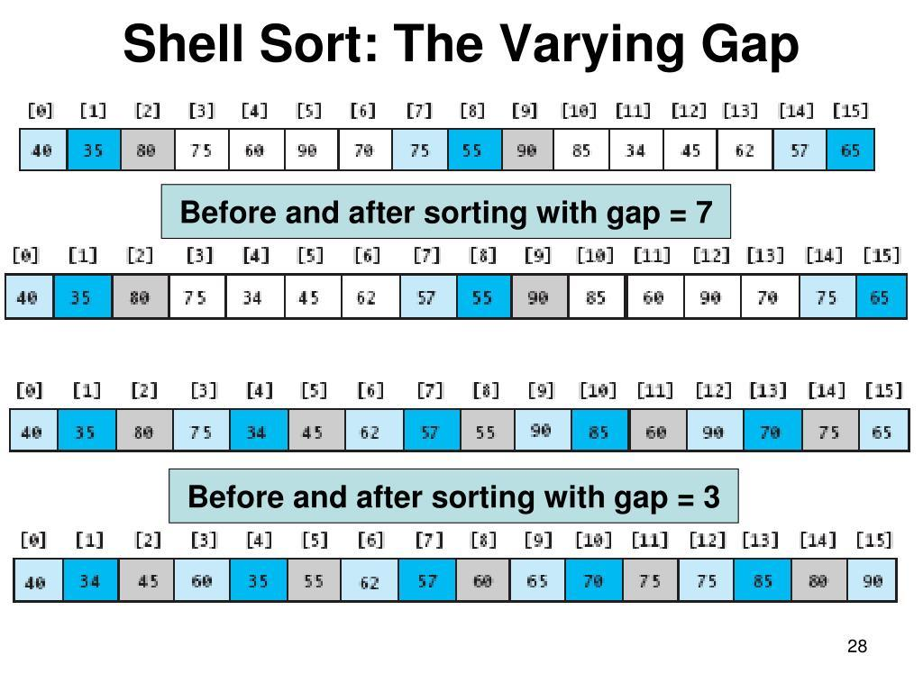
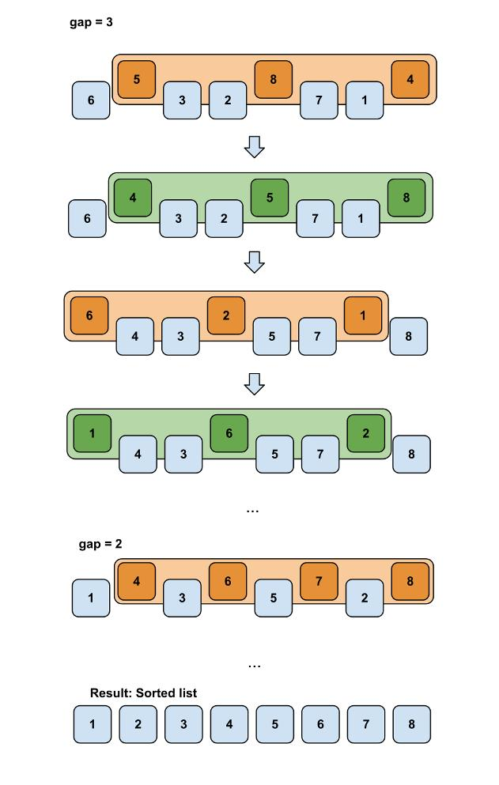
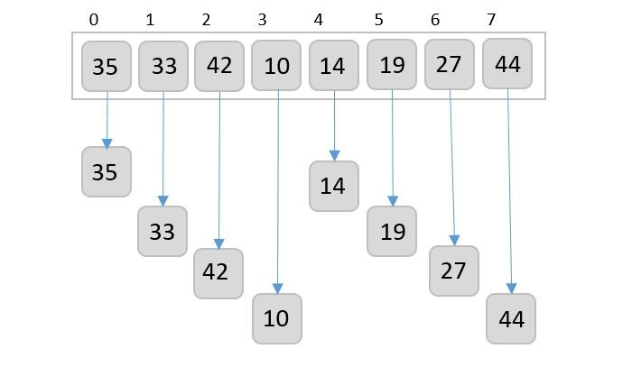
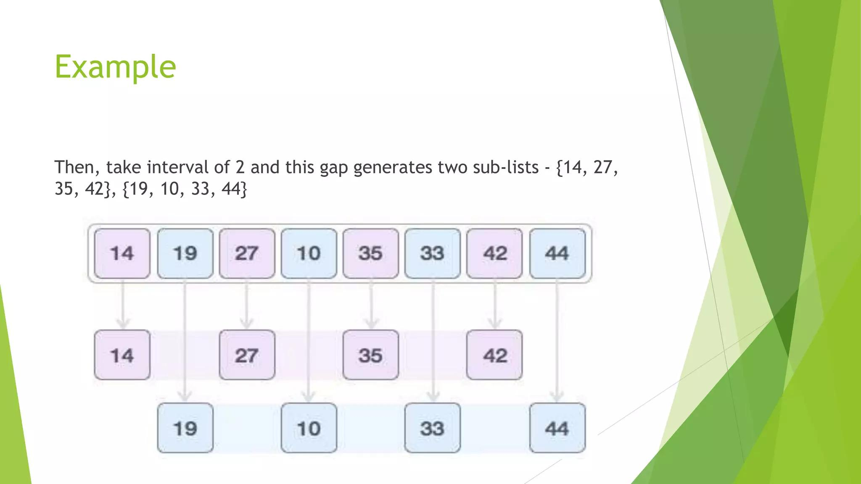
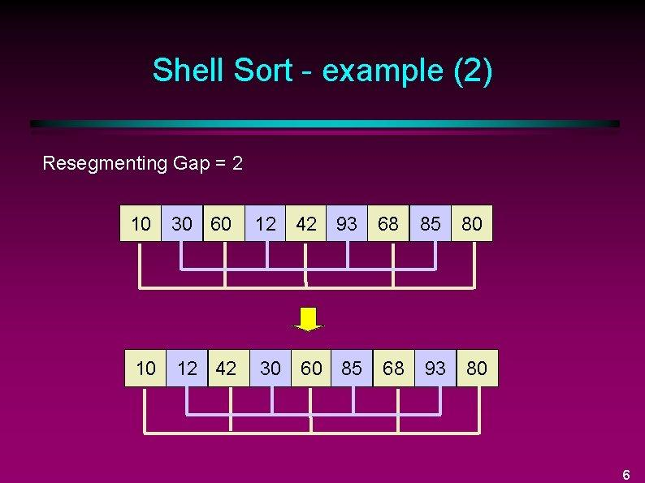
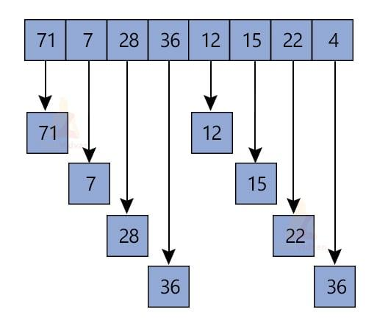
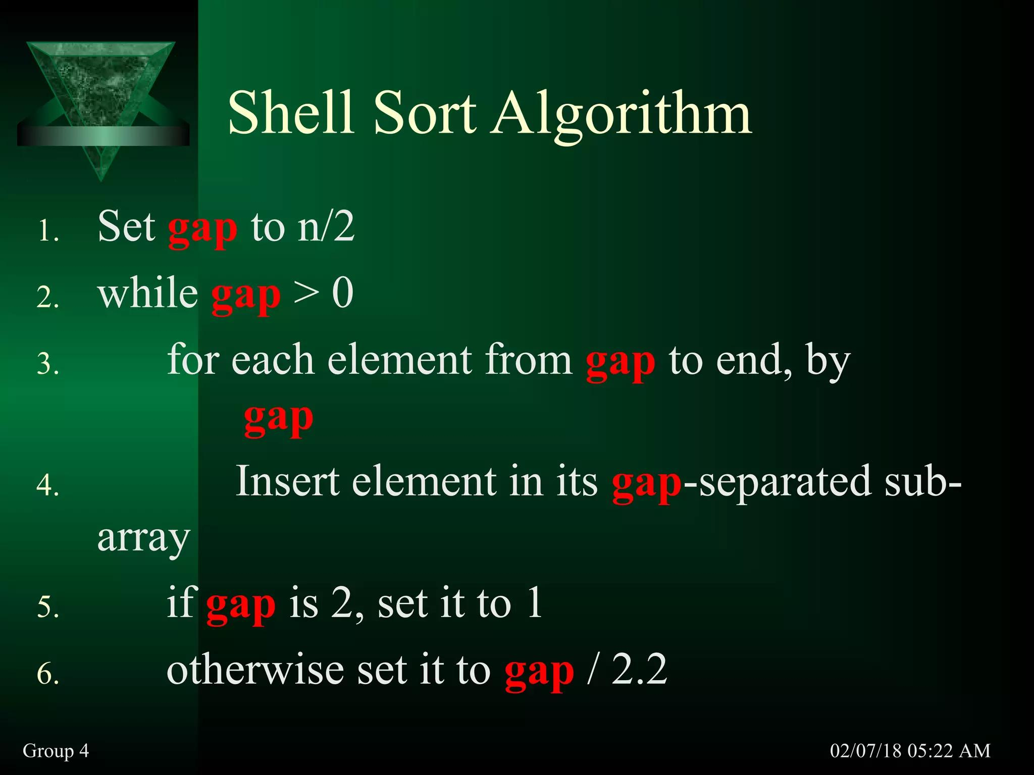
💡 Core Idea
- Instead of comparing neighbors (like Bubble)
- Instead of inserting one by one (like Insertion)
👉 You:
- Compare elements far apart (gap)
- Sort those groups
- Reduce gap
- Repeat
✔ Eventually becomes normal Insertion Sort (gap = 1)

🔄 PART 1: Algorithm Step-by-Step
Let’s take:
[64, 25, 12, 22, 11]

🔹 Step 1: Initial Gap = n / 2
gap = 5 / 2 = 2
👉 Groups:
Group 1: [64, 12, 11]
Group 2: [25, 22]

🔹 Step 2: Sort Each Group (Insertion Style)
Group 1:
[64, 12, 11] → [11, 12, 64]
Group 2:
[25, 22] → [22, 25]
👉 Combined array:
[11, 22, 12, 25, 64]

🔹 Step 3: Reduce Gap
gap = 2 / 2 = 1

🔹 Step 4: Normal Insertion Sort
[11, 22, 12, 25, 64]
👉 Insert 12 correctly:
[11, 12, 22, 25, 64]
✔ Sorted!

🧾 PART 2: Your Code
public void shellsort(int[] A, int n)
{
int gap = n / 2;

while (gap > 0)
{
int i = gap;

while (i < n)
{
int temp = A[i];
int j = i - gap;

while (j >= 0 && A[j] > temp)
{
A[j + gap] = A[j];
j = j - gap;
}

A[j + gap] = temp;
i = i + 1;
}

gap = gap / 2;
}
}

🔍 PART 3: Code Explanation (Line-by-Line)

🔹 1. Initialize Gap
int gap = n / 2;
👉 Start with large gap
👉 Compare elements far apart

🔹 2. Outer While → Gap Reduction
while (gap > 0)
👉 Repeat until gap becomes 1 → then 0

🔹 3. Start from Index = gap
int i = gap;
👉 First element that has a “previous gap element”

🔹 4. Traverse Array
while (i < n)
👉 Like insertion sort loop

🔹 5. Store Element
int temp = A[i];
👉 Pick element to insert

🔹 6. Compare with Gap Distance
int j = i - gap;
👉 Jump back by gap

🔹 7. While Loop (Core Logic)
while (j >= 0 && A[j] > temp)
👉 Same as insertion sort BUT:
- Instead of j--
- You do j = j - gap

🔹 8. Shift Elements
A[j + gap] = A[j];
j = j - gap;
👉 Shift elements by gap distance
📦 Example:
[64, _, 12, _, 11]

🔹 9. Insert Element
A[j + gap] = temp;
👉 Place element in correct gap position

🔹 10. Move Forward
i = i + 1;
👉 Move to next element

🔹 11. Reduce Gap
gap = gap / 2;
👉 Eventually becomes:
gap = 1 → insertion sort

🧠 Mental Mapping
Code | Real Meaning
gap | Distance between compared elements
i | Current element
temp | Element to insert
j | Compare index (gap-based)
shift | Move elements right
insert | Place correctly

📊 PART 4: Complexity Analysis

⏱ Time Complexity
Worst Case
O(n^2)

Best Case
O(n \log n)

Average Case
≈ O(n^1.3 to n^1.5)
👉 Depends on gap sequence

💾 Space Complexity
O(1)
👉 In-place sorting

⚡ Key Insight (Very Important)
- Shell Sort = Improved Insertion Sort
- Why faster?
  - Moves elements long distances early
  - Reduces total shifts later

🧩 Developer Insight
- Performance depends heavily on gap sequence
- Your version uses:
gap = gap / 2
👉 Simple but not optimal
👉 Better sequences exist (like Knuth sequence)

🚀 Final Understanding
- Bubble → swap neighbors ❌
- Insertion → shift one-by-one ⚠️
- Shell → jump + shift efficiently ✅

If you want next:
- I can compare all 4 sorts (Selection, Insertion, Bubble, Shell) in one visual table
- Or build a step-by-step execution trace (i, j, gap changes) for exam prep

